Private Real Estate Investing Builds Wealth While Improving Our Communities

Millennium Capital Investments, LLC is a local Cleveland company that purchases and renovates residential properties throughout Cuyahoga and Medina Counties just like this one. In fact, here is one of our properties we recently completed renovations on.

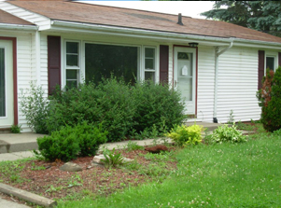  Before | 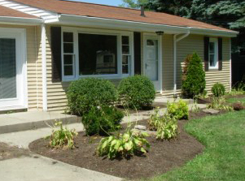  After
Many of our properties are funded with mortgage companies and banks, such as Chase, Bank of America and Wells Fargo. In addition, many of our properties are funded with private investors like yourself.

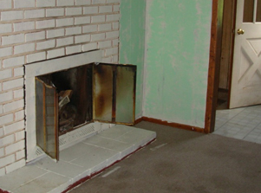  Before | 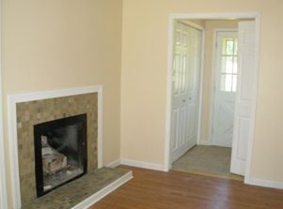  After

Banks pay their investors 1% to 2% on CD’s (Certificates of Deposit). Then the banks lend the money out to you and I at 5% to 8%. They make the spread between what they pay on a CD and what they charge borrowers.

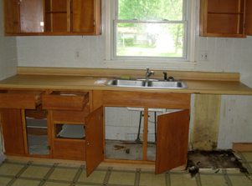  Before | 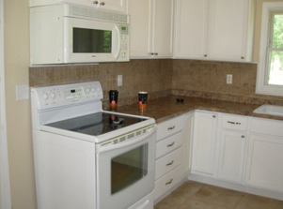  After

At Millennium Capital Investments, LLC , our investors earn 9.5% fixed up to five years. We also work with many investors who have IRA funds available, so they can take full advantage of the tax-deferral status for retirement savings.

Call us at 440-545-2071 to learn more about your investment options and/or to reserve a seat at one of our upcoming seminars. Find out what your banker and broker won’t tell you… how real estate really builds wealth.

Millennium Capital Investments, LLC
6659 Pearl Road Suite 202 Parma Hts Ohio
Phone: 440-545-2071 Email: jcantwell@srecnow.com

