COMPANY LEADERSHIP

A native of Northeast Ohio, Josh Cantwell graduated from Baldwin Wallace College in 1998 with a Major in Business Administration and a Minor in Communications. Although a full-time student and college athlete, Josh was already driven to succeed in his career. After graduation he obtained his Series 6, 63, 66 and life and health insurance licenses, and worked as a Financial Advisor from 1999-2004.
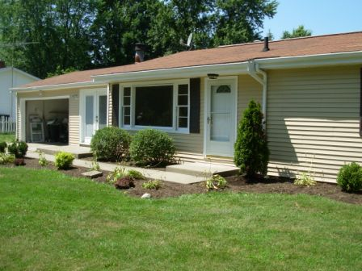
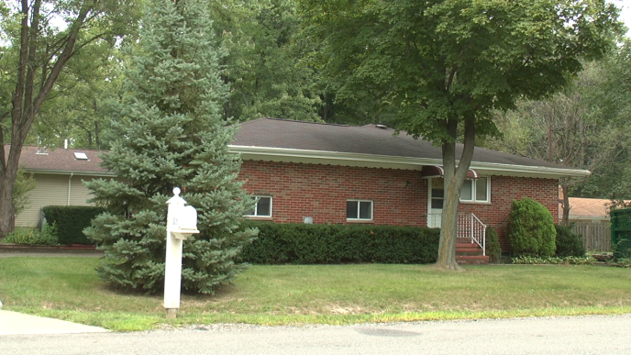


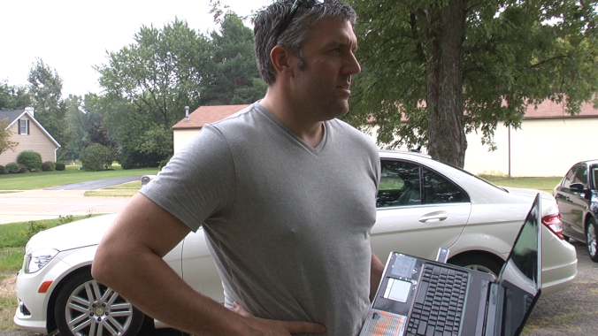
In 2004, Josh took his knowledge of raising capital and the financial markets and started investing in real estate full time. He was able to combine his knowledge of Financial Investing with real estate to create a very successful business, which quickly grew. In turn he began training and teaching apprentice partners and students. He founded Strategic Real Estate Coach in 2007, and since then has been involved in 600+ wholesale, rehab, rental, foreclosure, pre-foreclosure and short sale transactions, and taught thousands of investors how to replicate his success. Josh has vast knowledge and experience in helping coaching clients, mentor students and apprentice partners from across the US in finding, structuring, negotiating and closing various types of transactions for a profit.
He has bought and sold over 600 properties in 25 states, and currently holds a robust rental portfolio of cash-flowing properties. He is the founder of Sharp Concepts Realty, the fastest growing real estate brokerage in the Greater Cleveland, Ohio area. Josh lives in Strongsville, Ohio with his wife Lisa Marie and three children.

