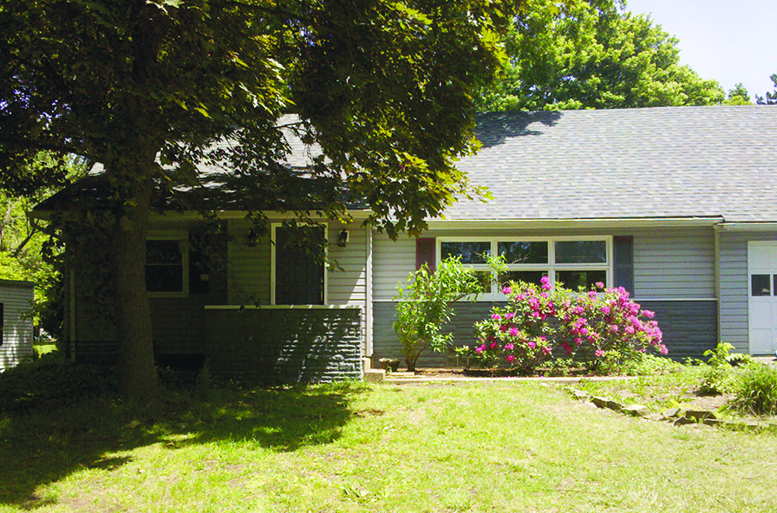
PURCHASE PRICE - $56,905
RENOVATIONS - $27,000
SOLD - $132,000
PROFIT - $39,000

FLORIDA ROOM:
BEFORE AFTER
BEDROOM:BEFORE
BATHROOM:BEFORE
KITCHEN: BEFORE KITCHEN: AFTER
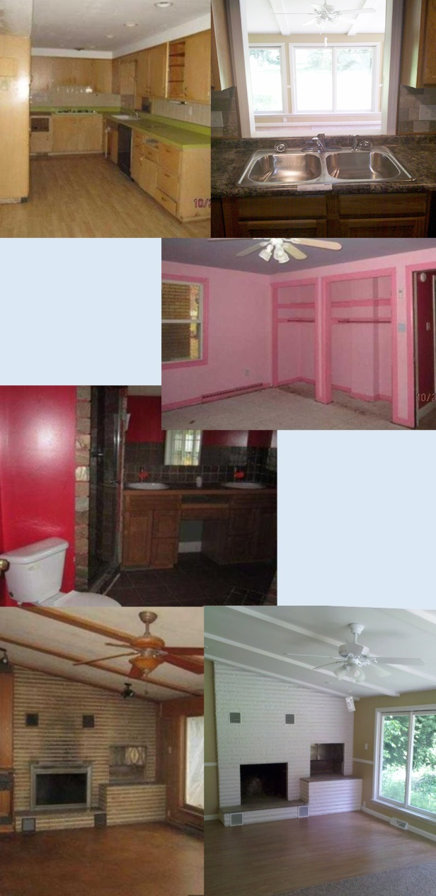
1171 Gardner Road is a large 4 bed, 3 bath Cape Cod near the center of Norton. This was a “good bones” property purchase – there weren’t any foundation problems and the house has good walls. Additionally, it has two fireplaces, a fantastic Florida room and a full basement that could be finished.

We purchased the property for $56,905 and spent $27,000 on renovations. We were into the property for $83,000. It sold for $132,000 giving us a profit of $39,000!

The entire house has been updated with new carpeting or laminate flooring and neutral paint. The fireplaces were cleaned up and refinished. We put in a new kitchen with stainless steel appliances, countertops and cabinets. See the before and after photos!
August 2013
GARDNER ROAD SOLD!
1171 Gardner Road, Norton

12% Returns
or Better
on Your Investments!

Call Josh TODAY if you’re thinking about buying or selling a house or you want to explore how to get 12% returns or better on your Retirement, Investment, CD, or Brokerage funds.
216.233.5448

Josh Cantwell
Founder and CEO of Millennium Capital Investments &
Sharp Concepts Realty



Solutions For a New Economy

Sit amet, consec tetuer adipiscing elit, sed diam nonummy nibh euismod
tincidunt ut laoreet dolore magna aliquam . Ut wisi enim ad minim veniam, quis nostrud exerci tation ullamcorper. Et iusto odio dignissim qui blandit praeseptatum zzril delenit augue duis dolore te feugait nulla adipiscing elit, sed diam nonummy nibh .

PERSONAL COMPUTING Tincidunt ut laoreet dolore magna aliquam erat volut pat. Ut wisi enim ad minim veniam, quis exerci tation ullamcorper cipit lobortis nisl ut aliquip ex
it amet, consec tetuer
adipiscing elit, sed diam nonummy nibh euismod
tincidunt ut laoreet dolore magna aliquam . Ut
wisi enim ad minim veniam,
quis nostrud exerci tation
ullamcorper. Et iusto odio
dignissim qui blandit
praeseptatum.
Solutions For a New Economy

Sit amet, consec tetuer adipiscing elit, sed diam nonummy nibh euismod
tincidunt ut laoreet dolore magna aliquam . Ut wisi enim ad minim veniam, quis nostrud exerci tation ullamcorper. Et iusto odio dignissim qui blandit praeseptatum zzril delenit augue duis dolore te feugait nulla adipiscing elit, sed diam nonummy nibh .

PERSONAL COMPUTING Tincidunt ut laoreet dolore magna aliquam erat volut pat. Ut wisi enim ad minim veniam, quis exerci tation ullamcorper cipit lobortis nisl ut aliquip ex
it amet, consec tetuer
adipiscing elit, sed diam nonummy nibh euismod
tincidunt ut laoreet dolore magna aliquam . Ut
wisi enim ad minim veniam,
quis nostrud exerci tation
ullamcorper. Et iusto odio
dignissim qui blandit
praeseptatum.
Solutions For a New Economy

Sit amet, consec tetuer adipiscing elit, sed diam nonummy nibh euismod
tincidunt ut laoreet dolore magna aliquam . Ut wisi enim ad minim veniam, quis nostrud exerci tation ullamcorper. Et iusto odio dignissim qui blandit praeseptatum zzril delenit augue duis dolore te feugait nulla adipiscing elit, sed diam nonummy nibh .

PERSONAL COMPUTING Tincidunt ut laoreet dolore magna aliquam erat volut pat. Ut wisi enim ad minim veniam, quis exerci tation ullamcorper cipit lobortis nisl ut aliquip ex
it amet, consec tetuer
adipiscing elit, sed diam nonummy nibh euismod
tincidunt ut laoreet dolore magna aliquam . Ut
wisi enim ad minim veniam,
quis nostrud exerci tation
ullamcorper. Et iusto odio
dignissim qui blandit
praeseptatum.
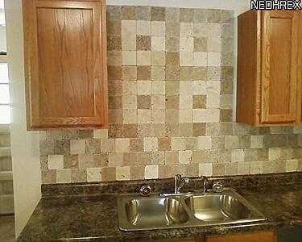
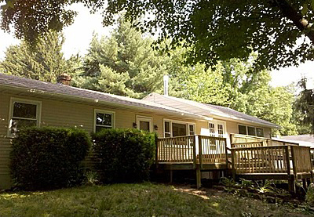
The kitchen has been updated with new ceramic tile flooring, countertops, all new appliances and a custom, tile backsplash.
Purchase Price - $41,500
Renovations - $37,000
Total Investment - $78,500
SOLD - $124,000
PROFIT - $33,000
3954 Homestead Road, Ravenna
This Homestead Road property is a large, 4 bedroom/2 bath raised ranch on 1.5 acre lot. We purchased it for $41,500 and put $37,000 into it for renovations. This house was a wreck when we bought it. We completely gutted it then renovated both the exterior and interior. Additionally we put a new roof on, replaced the windows and siding and installed new garage doors.

This house has 3 beautiful decks – 1 in the front of the house and 2 overlooking the backyard.
All three decks have been completely redone.

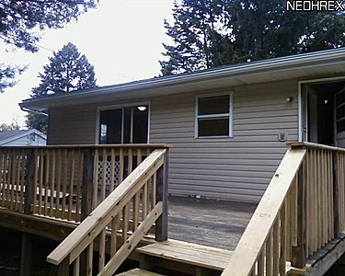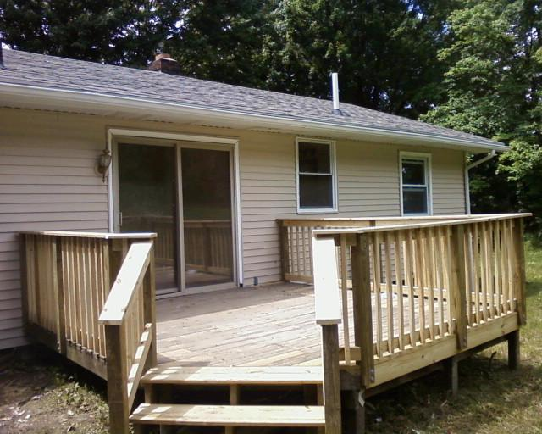
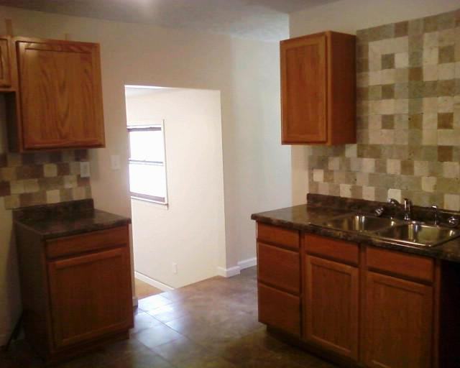
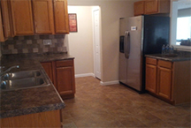
Both of the bathrooms were gutted. New flooring, windows, vanities, hardware and lighting were added.
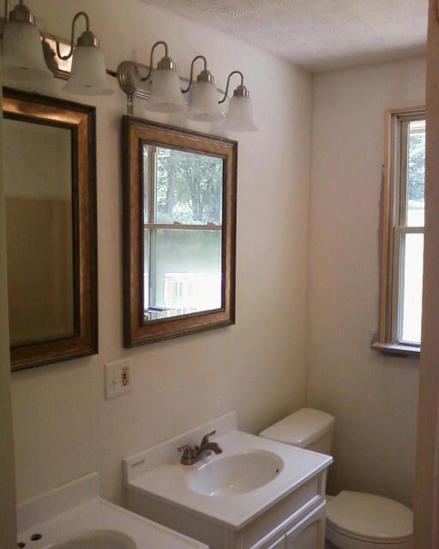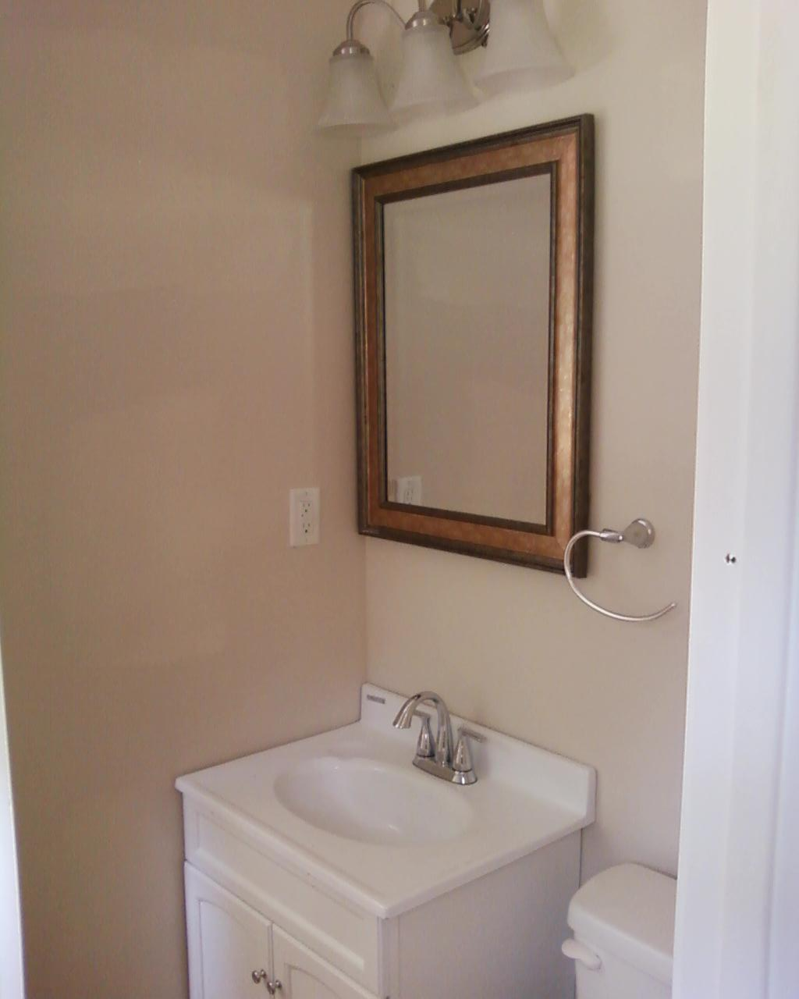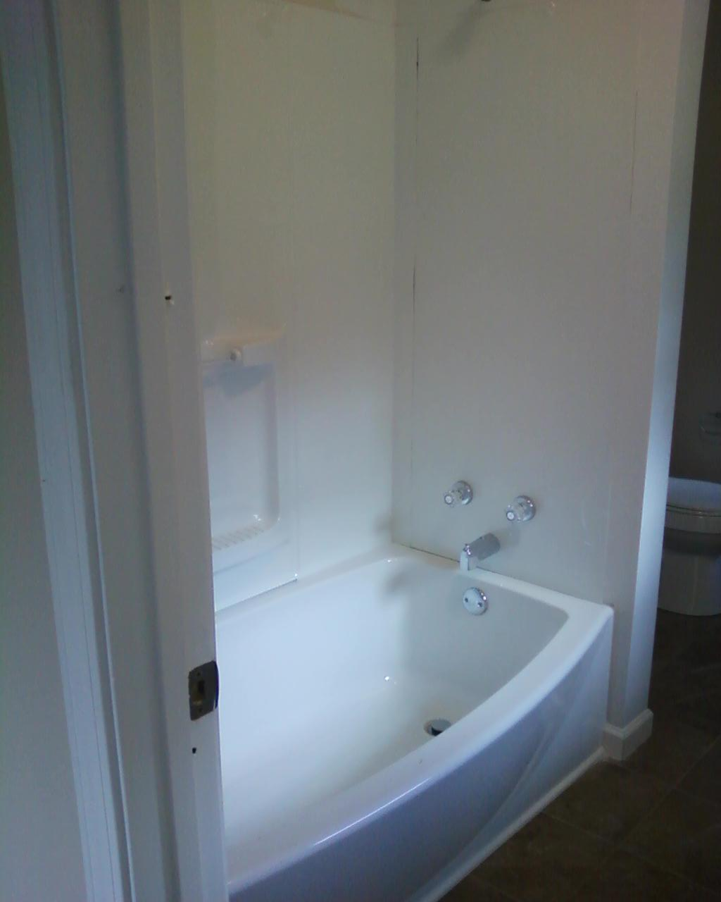

Purchase Price - $50,500
Renovations - $33,000
Total Investment - $63,500
Listed For - $149,900
Net Profit Goal - $40,000
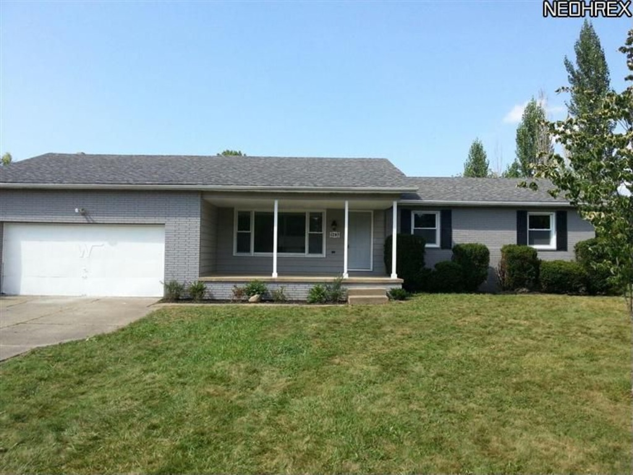
BASEMENT: BEFORE
LIVING ROOM LIVING ROOM: AFTER
LIVING ROOM: BEFORE
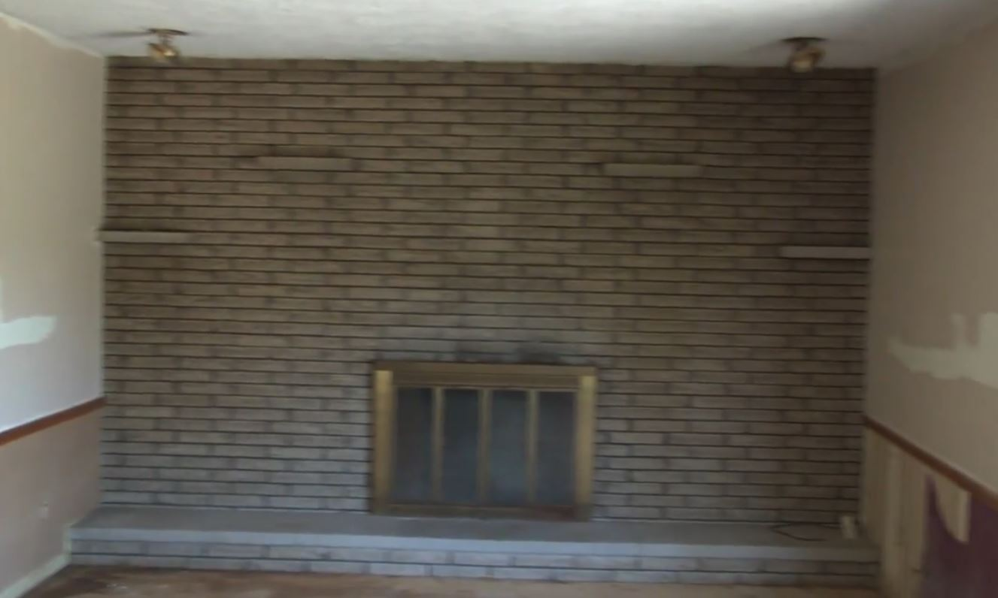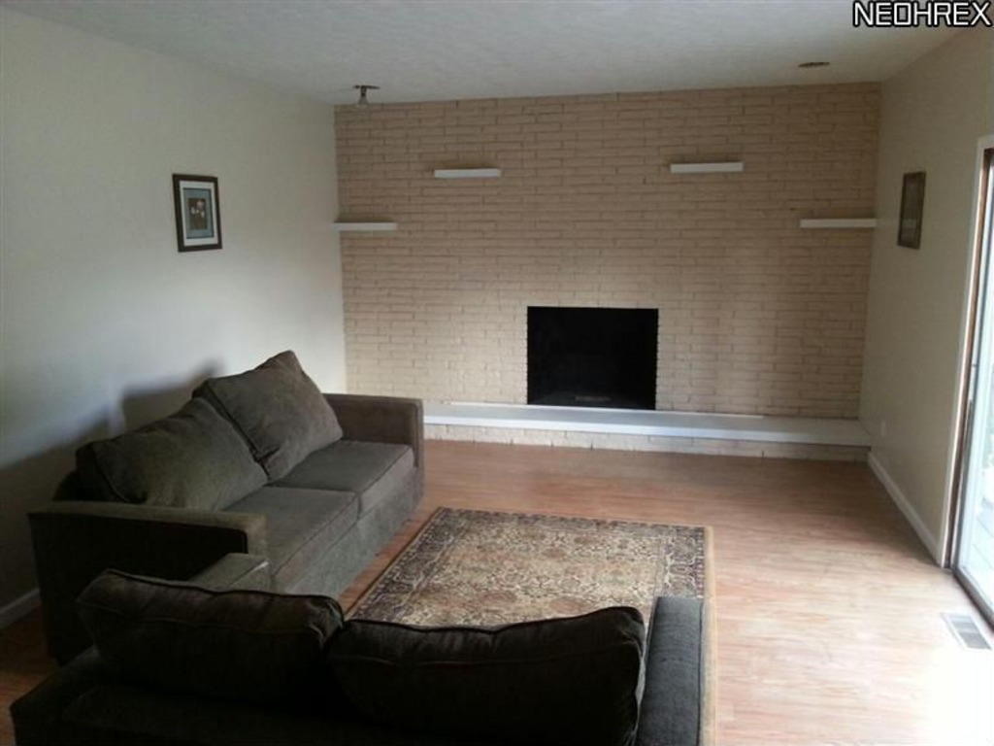
KITCHEN: AFTER
EXTERIOR: BEFORE
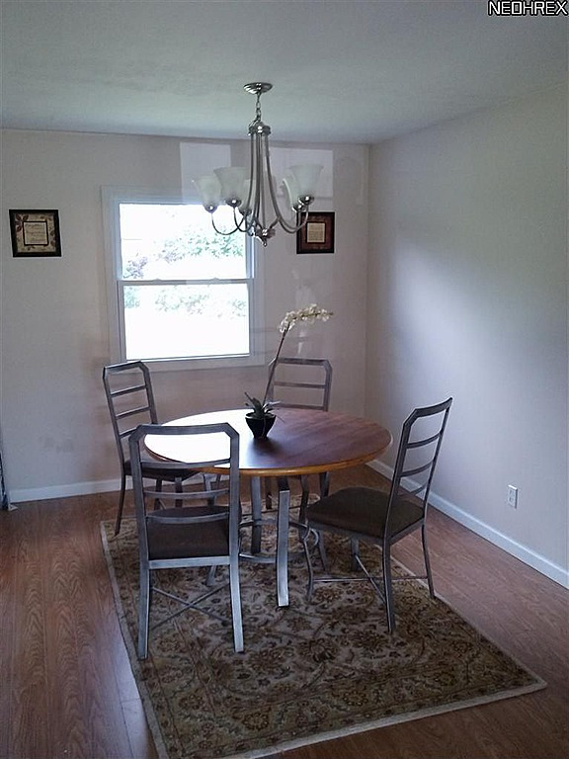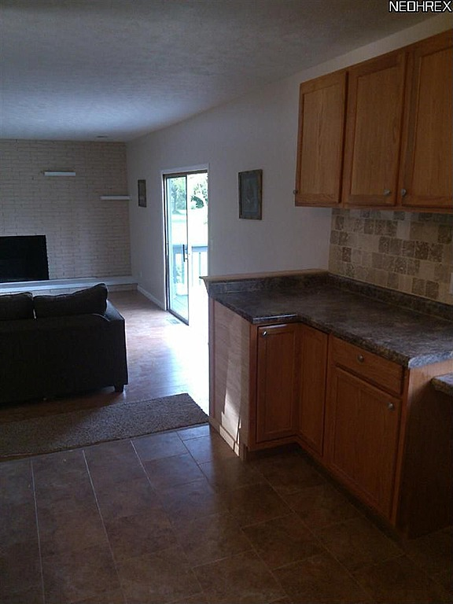
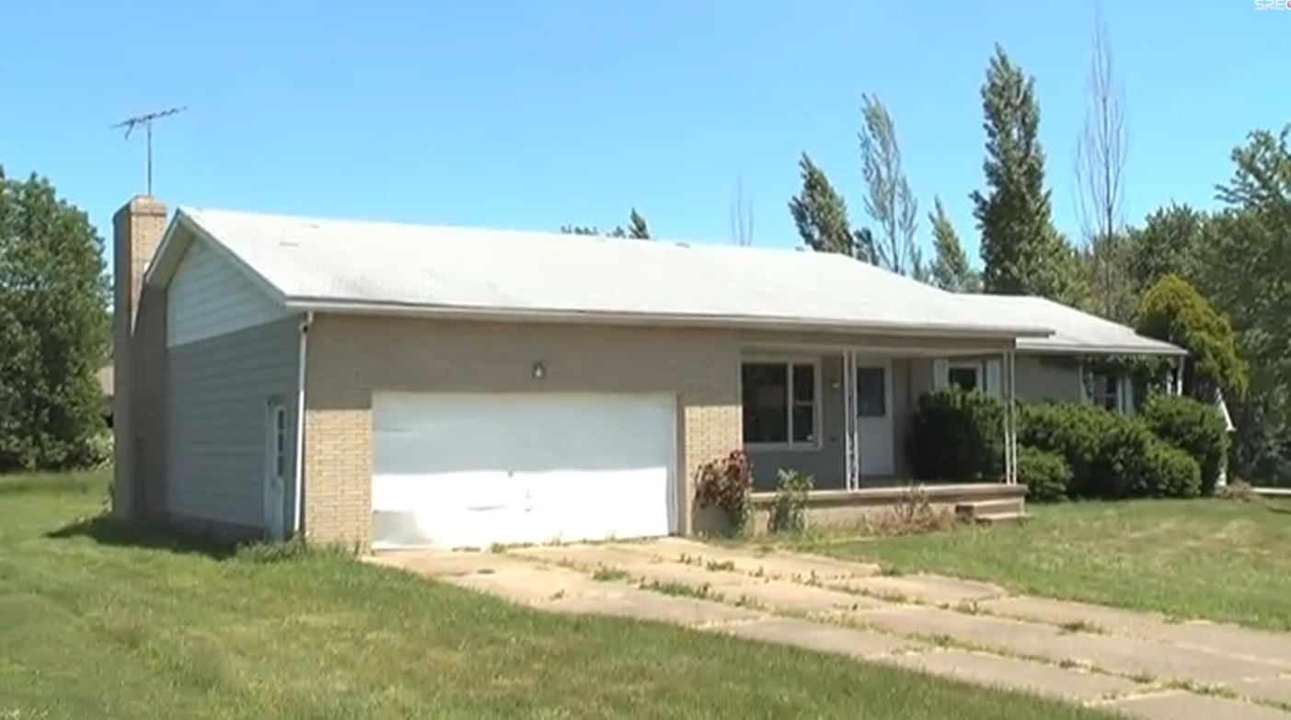
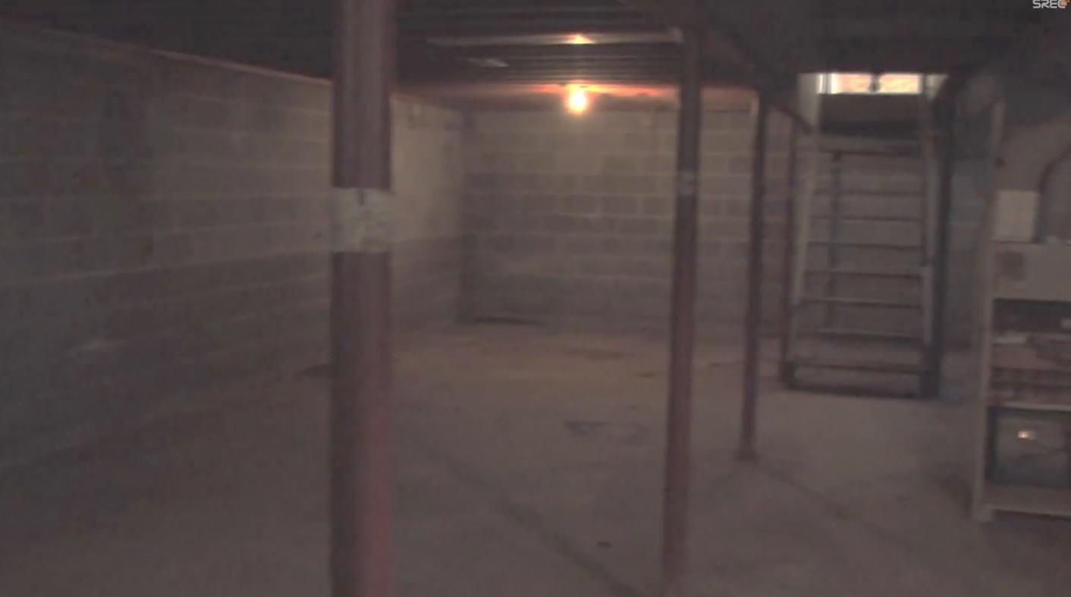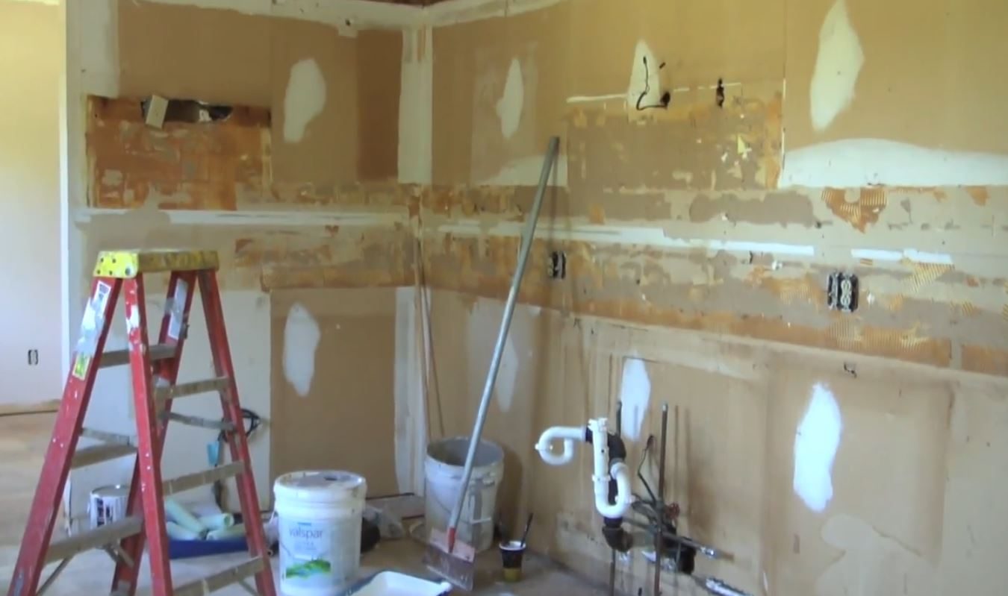
1297 Steve Drive was bought for $50,000 as a bank foreclosure with money from a private lender. We put $33,000 worth of renovations into the house. The property is listed at $149,900. We anticipate a net profit of $40,000.
The renovations included updating the kitchen with oak cabinets, countertops, stainless steel appliances, a tile backsplash and tile flooring. We installed new carpet and maple laminate flooring throughout the house. The bathrooms have all been updated with new fixtures, flooring and paint.
$7,000 of the renovation budget went into finishing half of the basement. By doing this, our asking price shot up from $129,900 to $149,900 making it easily worth the money to clean up and finish off half the basement. The extra $7,000 we put into the basement allowed us to increase the asking price by over $20,000… a 3 to 1 return on investment in this real estate investment. We also added an office for the “work from home” homeowner.

1297 Steve Drive, Akron
BEDROOM: BEFORE
BATHROOM: AFTER
FLOORING: BEFORE
LIVING ROOM: AFTER
LIVING ROOM: BEFORE
KITCHEN: AFTER
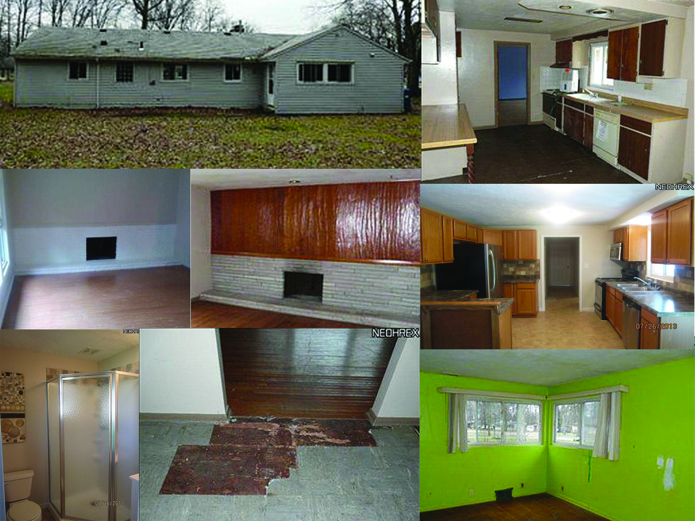
This Edgewood Drive property is rather small – 1,275 sq. ft. The small size allowed us to complete the renovations in 6 weeks. We updated the house with our standard renovations – new kitchen with stainless steel appliances, new carpeting and laminate flooring throughout the house, a neutral paint scheme on all of the walls. Additionally, we converted a large living space into a third bedroom that has access to the back yard.

EXTERIOR: BEFORE
KITCHEN: BEFORE
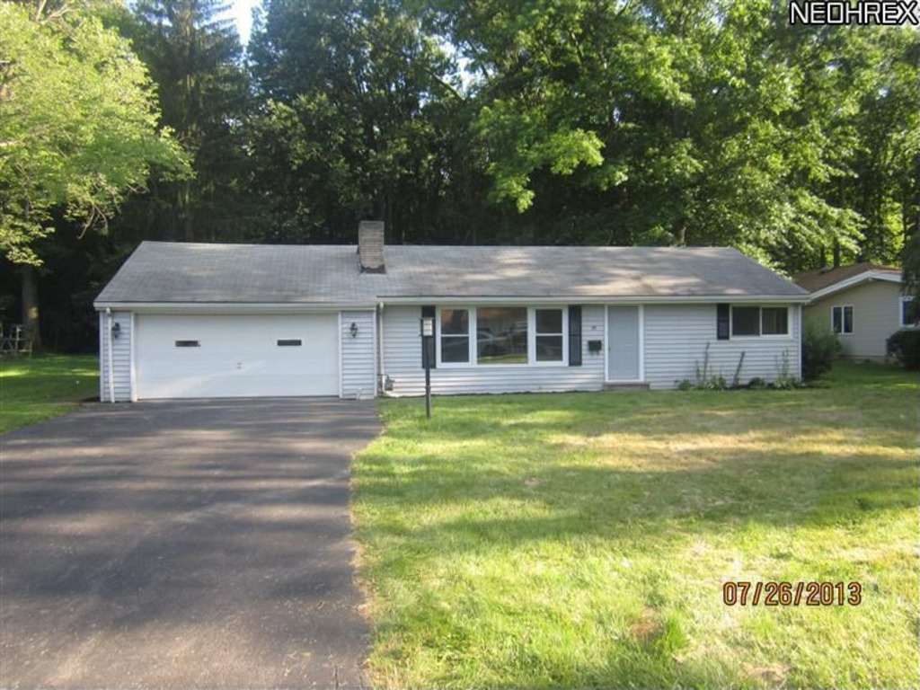
Purchase Price - $41,000
Renovations - $25,000
Total Investment - $66,000
Listed For - $124,900
Net Profit Goal - $35,000

38 Edgewood Drive, Grafton

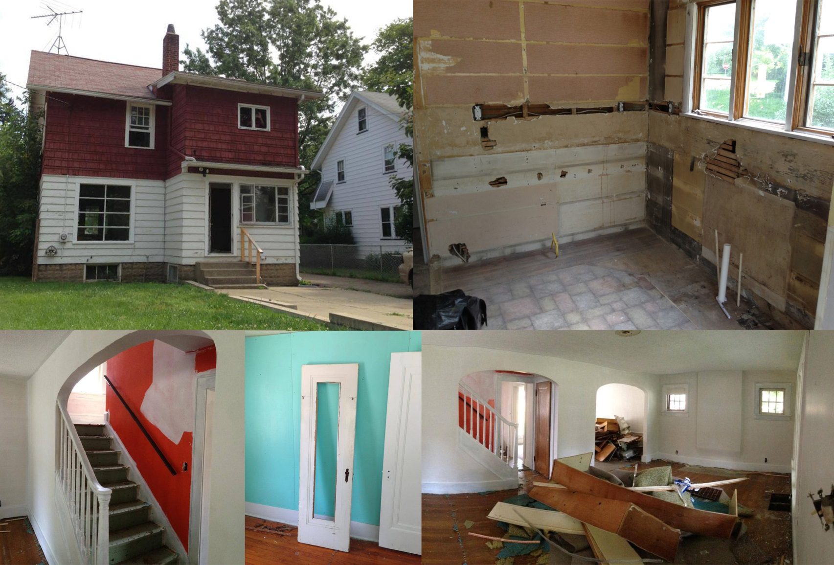
We started demolition on 2312 Iota Avenue in July. The exterior of the house is getting a new coat of paint, we are fixing the detached garage and tearing down the existing pool. Inside the house we are repairing drywall and painting all of the walls a neutral color. The kitchen will be updated with new countertops, cabinets, stainless steel appliances and laminate flooring. Both of the bathrooms will get new fixtures, windows and laminate flooring. When we tore into the walls we realized that all of the electrical and plumbing needs to be redone throughout the whole house. Below are photos from our renovation so far.

Purchase Price - $53,000
Renovation Budget - $31,000
Expected List Price - $139,900
Net Profit Goal - $56,000

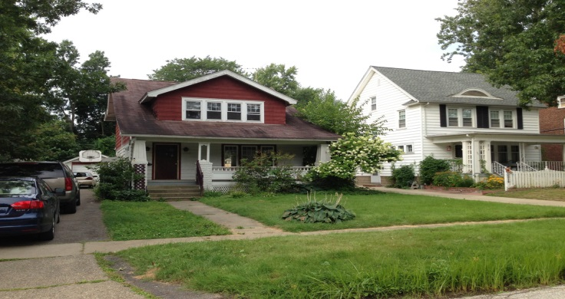
2312 Iota Avenue, Cuyahoga Falls
















Millennium Capital Investments

P.O. Box 30339 Middleburg Heights, OH 44130
Ph: 216.233.5448 | Fax: 440.888.7851
jcantwell@srecnow.com | www.millenniumcapitalinvestments.net

- Follow Us Online -
STRATEGIC REAL ESTATE COACH main blog: www.strategicrealestatecoach.com
TOP REAL ESTATE INVESTOR blog: www.toprealestateinvestor.com
SREC FACEBOOK FAN PAGE: www.facebook.com/Srecnow
STRATEGIC REAL ESTATE COACH – YouTube: www.youtube.com/SRECvideo
JOSH CANTWELL – Facebook Fan Page: www.facebook.com/josh.cantwell1
JOSH CANTWELL – Twitter: www.twitter.com/joshcantwell
JOSH CANTWELL – LinkedIn: www.linkedin.com/in/joshcantwell
SHARP CONCEPTS REALTY: www.freeclevelandhomesearch.com
Visit the iTunes App Store and download the STRATEGIC REAL ESTATE COACH APP
SREC PODCAST at itunes.apple.com/us/podcast/strategic-real-estate-ch/id570750792?mt=2



P.O. Box 30339

Middleburg Hts., OH 44130

Solutions For a New Economy

Sit amet, consec tetuer adipiscing elit, sed diam nonummy nibh euismod
tincidunt ut laoreet dolore magna aliquam . Ut wisi enim ad minim veniam, quis nostrud exerci tation ullamcorper. Et iusto odio dignissim qui blandit praeseptatum zzril delenit augue duis dolore te feugait nulla adipiscing elit, sed diam nonummy nibh .

PERSONAL COMPUTING Tincidunt ut laoreet dolore magna aliquam erat volut pat. Ut wisi enim ad minim veniam, quis exerci tation ullamcorper cipit lobortis nisl ut aliquip ex
it amet, consec tetuer
adipiscing elit, sed diam nonummy nibh euismod
tincidunt ut laoreet dolore magna aliquam . Ut
wisi enim ad minim veniam,
quis nostrud exerci tation
ullamcorper. Et iusto odio
dignissim qui blandit
praeseptatum.
Solutions For a New Economy

Sit amet, consec tetuer adipiscing elit, sed diam nonummy nibh euismod
tincidunt ut laoreet dolore magna aliquam . Ut wisi enim ad minim veniam, quis nostrud exerci tation ullamcorper. Et iusto odio dignissim qui blandit praeseptatum zzril delenit augue duis dolore te feugait nulla adipiscing elit, sed diam nonummy nibh .

PERSONAL COMPUTING Tincidunt ut laoreet dolore magna aliquam erat volut pat. Ut wisi enim ad minim veniam, quis exerci tation ullamcorper cipit lobortis nisl ut aliquip ex
it amet, consec tetuer
adipiscing elit, sed diam nonummy nibh euismod
tincidunt ut laoreet dolore magna aliquam . Ut
wisi enim ad minim veniam,
quis nostrud exerci tation
ullamcorper. Et iusto odio
dignissim qui blandit
praeseptatum.
Solutions For a New Economy

Sit amet, consec tetuer adipiscing elit, sed diam nonummy nibh euismod
tincidunt ut laoreet dolore magna aliquam . Ut wisi enim ad minim veniam, quis nostrud exerci tation ullamcorper. Et iusto odio dignissim qui blandit praeseptatum zzril delenit augue duis dolore te feugait nulla adipiscing elit, sed diam nonummy nibh .

PERSONAL COMPUTING Tincidunt ut laoreet dolore magna aliquam erat volut pat. Ut wisi enim ad minim veniam, quis exerci tation ullamcorper cipit lobortis nisl ut aliquip ex
it amet, consec tetuer
adipiscing elit, sed diam nonummy nibh euismod
tincidunt ut laoreet dolore magna aliquam . Ut
wisi enim ad minim veniam,
quis nostrud exerci tation
ullamcorper. Et iusto odio
dignissim qui blandit
praeseptatum.

